Log-Based Recovery
- The log is a sequence of records. Log of each transaction is maintained in some stable storage so that if any failure occurs, then it can be recovered from there.
- If any operation is performed on the database, then it will be recorded in the log.
- But the process of storing the logs should be done before the actual transaction is applied in the database.
Let's assume there is a transaction to modify the City of a student. The following logs are written for this transaction.
- When the transaction is initiated, then it writes 'start' log.
  - <Tn, Start>
- When the transaction modifies the City from 'Noida' to 'Bangalore', then another log is written to the file.
  - <Tn, City, 'Noida', 'Bangalore' >
- When the transaction is finished, then it writes another log to indicate the end of the transaction.
  - <Tn, Commit>
There are two approaches to modify the database:

1. Deferred database modification:
- The deferred modification technique occurs if the transaction does not modify the database until it has committed.
- In this method, all the logs are created and stored in the stable storage, and the database is updated when a transaction commits.

2. Immediate database modification:
- The Immediate modification technique occurs if database modification occurs while the transaction is still active.
- In this technique, the database is modified immediately after every operation. It follows an actual database modification.

Recovery using Log records
When the system is crashed, then the system consults the log to find which transactions need to be undone and which need to be redone
If the log contains the record <Ti, Start> and <Ti, Commit> or <Ti, Commit>, then the Transaction Ti needs to be redone.
- If log contains record<Tn, Start> but does not contain the record either <Ti, commit> or <Ti, abort>, then the Transaction Ti needs to be undone.

Checkpoint
- The checkpoint is a type of mechanism where all the previous logs are removed from the system and permanently stored in the storage disk.
- The checkpoint is like a bookmark. While the execution of the transaction, such checkpoints are marked, and the transaction is executed then using the steps of the transaction, the log files will be created.
- When it reaches to the checkpoint, then the transaction will be updated into the database, and till that point, the entire log file will be removed from the file. Then the log file is updated with the new step of transaction till next checkpoint and so on.
- The checkpoint is used to declare a point before which the DBMS was in the consistent state, and all transactions were committed.

Recovery using Checkpoint
In the following manner, a recovery system recovers the database from this failure:
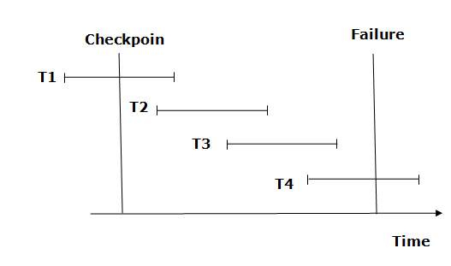
- The recovery system reads log files from the end to start. It reads log files from T4 to T1.
- Recovery system maintains two lists, a redo-list, and an undo-list.
- The transaction is put into redo state if the recovery system sees a log with <Tn, Start> and <Tn, Commit> or just <Tn, Commit>. In the redo-list and their previous list, all the transactions are removed and then redone before saving their logs.
- For example: In the log file, transaction T2 and T3 will have <Tn, Start> and <Tn, Commit>. The T1 transaction will have only <Tn, commit> in the log file. That's why the transaction is committed after the checkpoint is crossed. Hence it puts T1, T2 and T3 transaction into redo list.
- The transaction is put into undo state if the recovery system sees a log with <Tn, Start> but no commit or abort log found. In the undo-list, all the transactions are undone, and their logs are removed.
- For example: Transaction T4 will have <Tn, Start>. So T4 will be put into undo list since this transaction is not yet complete and failed amid.

- If the log contains the record <Ti, Start> and <Ti, Commit> or <Ti, Commit>, then the Transaction Ti needs to be redone.
- If log contains record<Tn, Start> but does not contain the record either <Ti, commit> or <Ti, abort>, then the Transaction Ti needs to be undone.

